
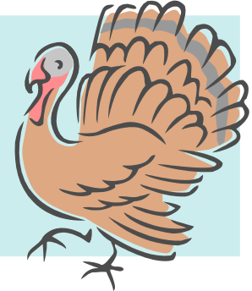
Mrs. Cunningham’s First Grade Advanced/Gifted
Newsletter & Homework Assignments
For the week of Nov. 5 - 9
Monday-
Read 10-15 minutes
and log time
Begin spelling
homework.

.

Spelling Words: Please find your student’s individual spelling list in his/her binder on Monday. Attached you will find the spelling homework options. Spelling homework is also always due on Friday. Thank you!




All homework due today. Spelling test today!
Thank you to all the parents that help all week in our room☺
Talent Development continues with focus on NATIONS- learning songs,
dances and making tunics.
Notes and News:
Please remember to reserve November 16th for our FEAST OF THE NATIONS. At 10:30 am we will be performing in the cafeteria. See the agenda and info attached. Can you make it? Please return the bottom portion of the paper by Friday, Nov. 19th. This is an event you won’t want to miss!

We want to encourage our students to be aware of the needs of the community around us. Fruitville will be participating in the Mayors’ Feed The Hungry effort and we will be collecting non-perishable food from Nov. 5th – 16th. Thank you in advance for any donations! 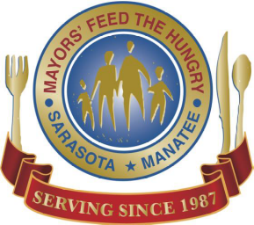
Thursday
Friday

Read 10-15 minutes and log time in your binder.
Study for your spelling test
All homework due tomorrow
Tuesday
Read 10-15 minutes and log time in your binder.
Review your new vocabulary words attached. Work on PROBLEM SOLVING
Word Problems- Compare Numbers Lesson 2.11. Lots of reading involved in this math!

Wednesday
New Math skill – Telling time to the hour and half hour -Lesson 7.8
Read 10-15 minutes and log time in your binder.

We are learning about the continents and countries of the world

